# Lab: Methods

Problems for in-class lab for the ["Programming Fundamentals and Unit Testing" course @ SoftUni](https://softuni.bg/trainings/4256/programming-fundamentals-and-unit-testing-september-2023)  
You can check your solutions in [Judge](https://judge.softuni.org/Contests/4348)

## Sign of Integer Numbers

In this task, you will **implement a method** to determine whether a given integer is **positive**, **negative**, or **zero**. Your task is to complete the provided skeleton class **SignIdentifier** by implementing the **SignOfInteger** method. A single integer is given as an input from the console. As a result print:

* For positive number: **"The number {number} is positive. "**
* For negative number: **"The number {number} is negative. "**
* For zero number: **"The number {number} is zero. "**

### Examples

|  |  |
| --- | --- |
| **Input** | **Output** |
| 2 | The number 2 is positive. |
| -9 | The number -9 is negative. |

## Instructions:

* Remember **not to delete any namespaces** or **change namings** in the skeleton.
* Locate the **SignOfInteger** method in the **SignIdentifier** class and **implement the programming logic** for it:

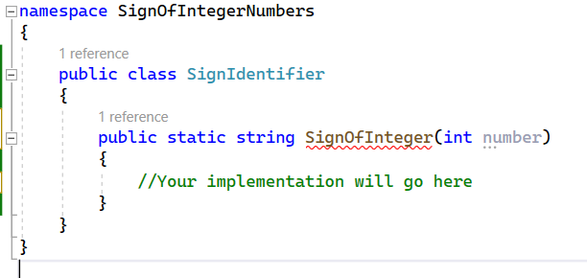

* Use **conditional statements** to determine whether the given integer is positive, negative, or zero:

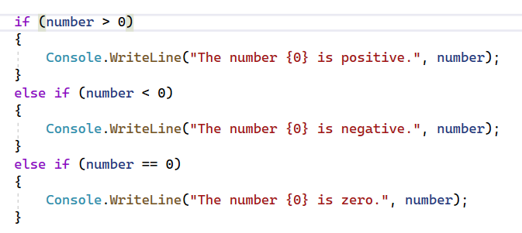

## Unit Testing – Sign of Integer Numbers

In this task, you will practice unit testing by creating test cases for the **SignOfInteger** method. You have already implemented the method that checks if a given integer is positive, negative, or zero. Now, your goal is to **ensure that this method works correctly** by writing **unit tests using NUnit**.

## Instructions:

* **Creating a New NUnit Test Project:**
  + In your solution, right-click on the solution in Solution Explorer:

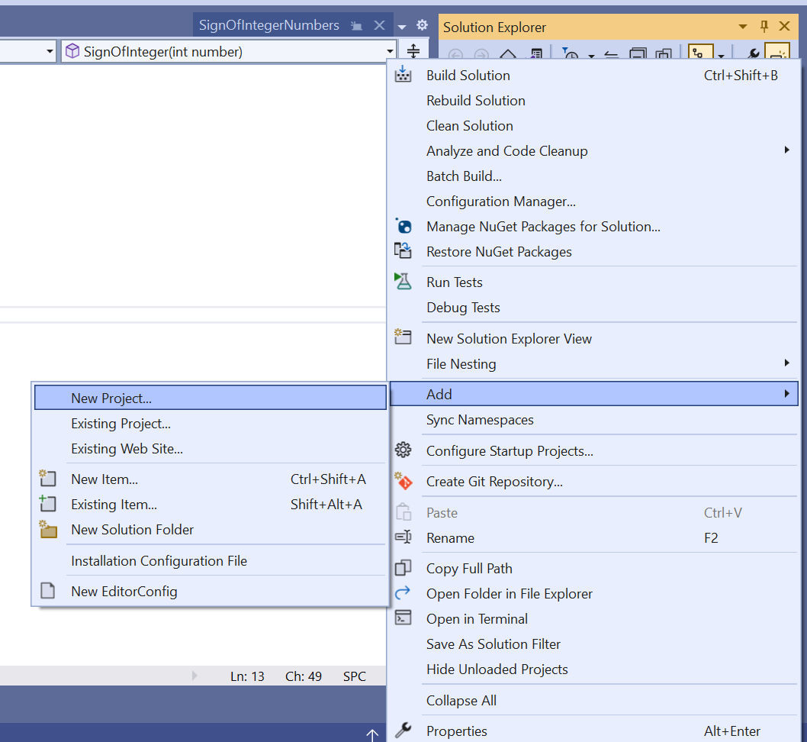

* + Select "Add" > "New Project..."
  + Choose the **"NUnit Test Project" template** under the "Test" category:

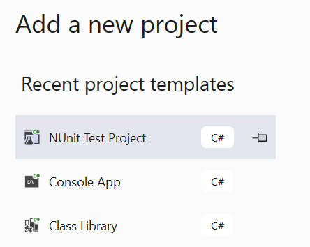

* **Name the project "SignOfIntegerNumbers.Tests"** and click "Next":

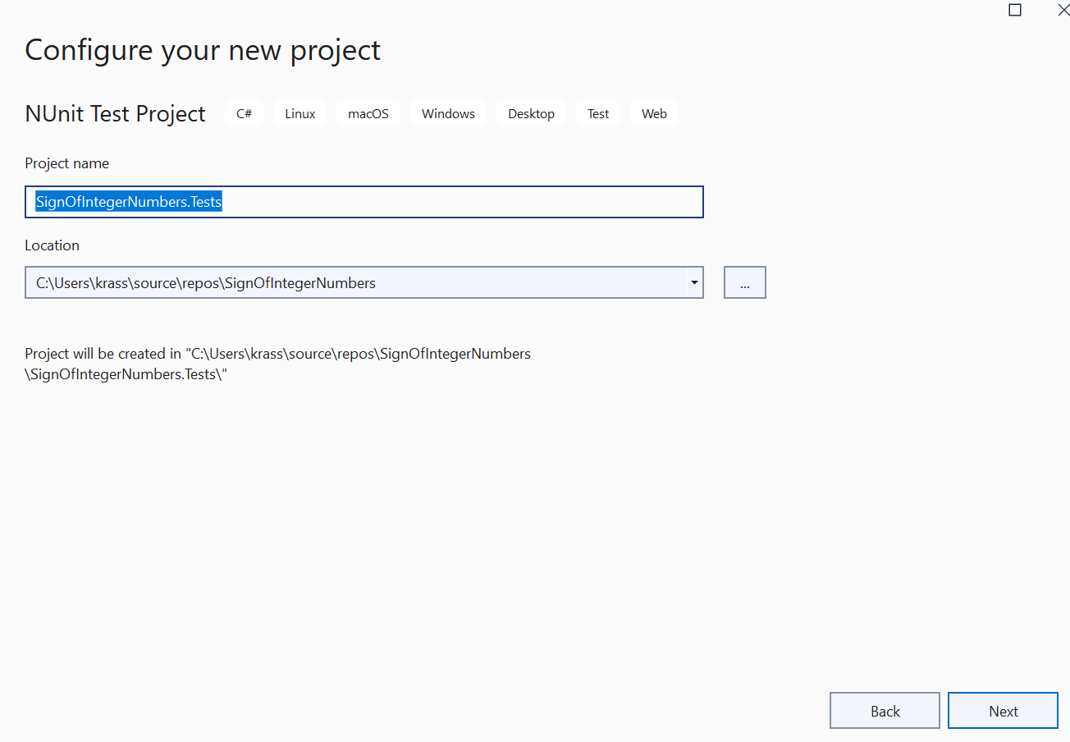

* Select the **".NET 6.0 (LTS)" version**, and click "Create":

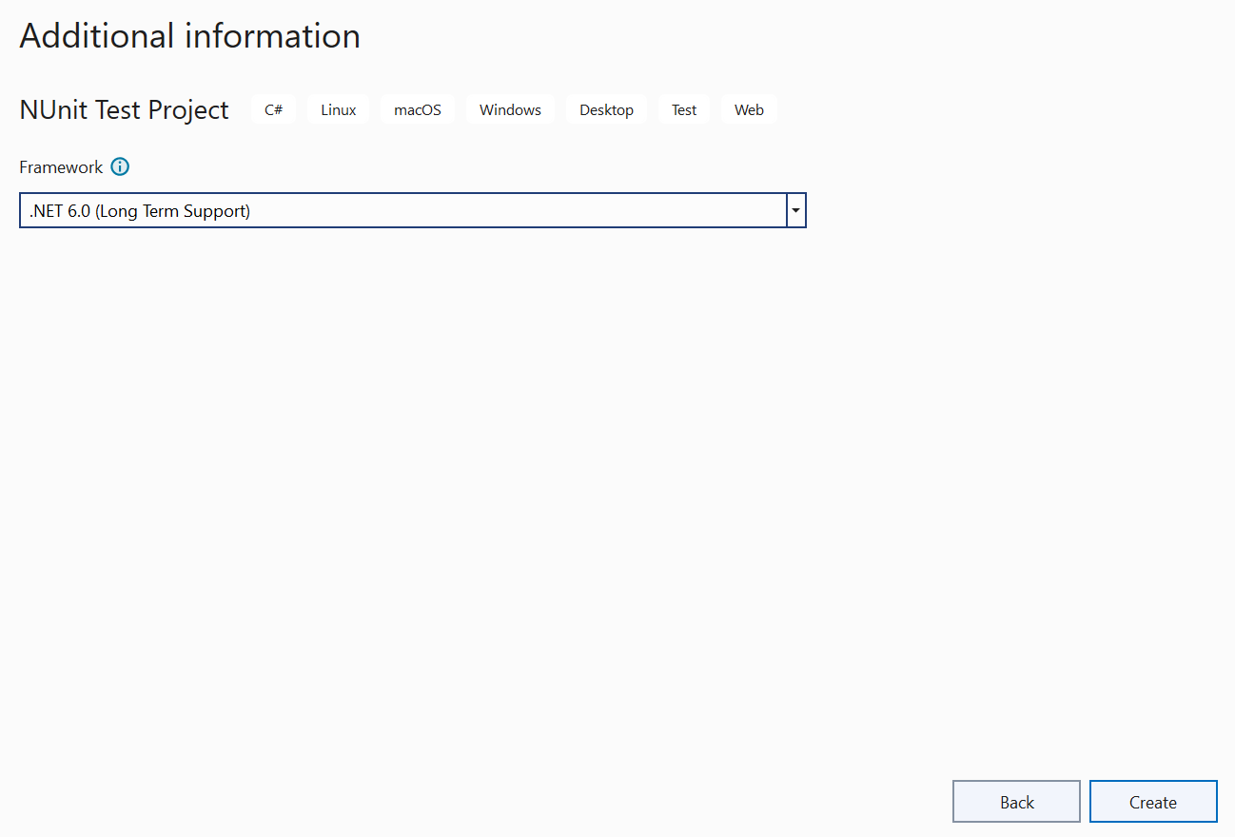

* **Referencing the Main Project:**
  + Right-click on the newly created test project and **select "Add" > "Project Reference"**

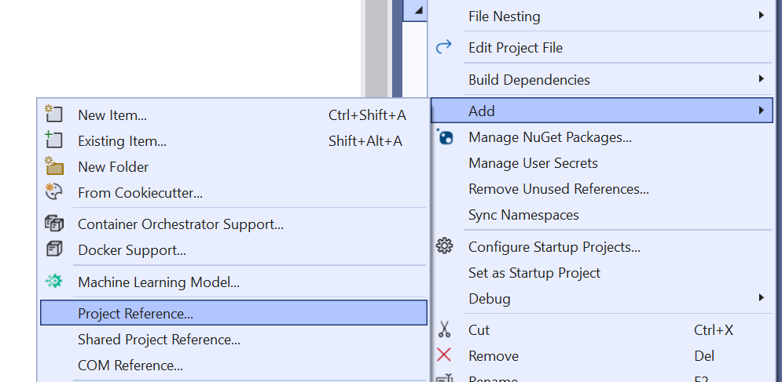

* + Choose your **main project** ("SignOfIntegerNumbers") to **reference it in the test project**. Click "OK":

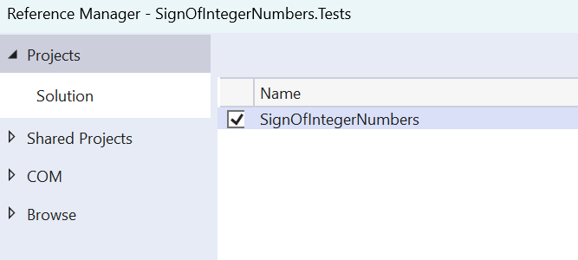

* In Judge, you upload **.zip** **(**with **SignOfIntegerNumbers.Tests** inside**)** from the **skeleton**